Dayton Hamvention - BMHA - Bike Ride 2009

Date: Saturday May 16, 2009
Time: 4 PM
Place: Wolf Creek Trail

By Arnie - KA0NCR
---------------------------------------------------
In past years, the BMHA group has organized a bike road ride over the Dayton Hamvention
weekend for anyone interested in bikes and ham radio. The past several years this has fallen
by the wayside as it seemed like it would always be raining on the Hamvention weekend, or
it was just to cold and miserable outside to think about riding.

Well, after having a couple of nice Hamvention weekends , several of the people on the BMHA E-mail reflector and Yahoo E-group were exchanging E-mail’s and brought forth the idea that it would be nice to try to have another BMHA bike ride. So, since no one jumped up to spearhead the organization of
the ride, I took the job of organizing something for the ride.

After checking on the roads and trails in the area, it was decided that a bike trail ride would appeal to more riders as it would have a good surface and would not have us riding in traffic, although you will have to cross some roads. Out of all the trails, it looked like the best one for us would be the Wolf Creek trail.
The trail has very gentle grades, and is 12 foot wide asphalt so road bikes need not fear gravel trails.

For more info, check out the trail website at:

http://www.miamivalleytrails.org/wolf.htm

I felt that the best time would be Saturday afternoon with a start time of 4 PM local time.
This should give people a fair amount of time all day Friday and Saturday morning and part of the afternoon to check out the Hamvention, while still giving time to get to the trail head.

The ride length and speed will be left up to the individual rider’s preference. You can even just set up your bike at the trail head and operate and not ride if you desire, or if the weather looks threatening just hang around and have a few “Eye-ball“ QSO‘s
.
The trail should provide about 25+ miles of travel for those of you who wish to ride to each end.
We plan to start at the trail head at the intersection of Arlington Rd and Upper Lewisburg Salem Rd, which is just off I-70 exit 21 at Brookville. This trail head has parking, and several places to eat near by. It is just across the street from Rob's Restaurant and from what I am told it is great and that it is frequented by the local bike club on their Saturday morning rides.. so that sounds like a great endorsement to me! We can plan to chow down at Rob’s after the ride.

The easiest way to get to the trail head from the Hamvention is to go west a few blocks from the Arena to Salem Ave. and then head north to I-70. Proceed west on I-70 to Exit - 21. Take the off ramp, go south over the Interstate and proceed 1 block south to the trail head at Golden Gate park. The trail head will be on the east side of the road just before you cross the Upper Lewisburg/Salem road way.

See the map below:
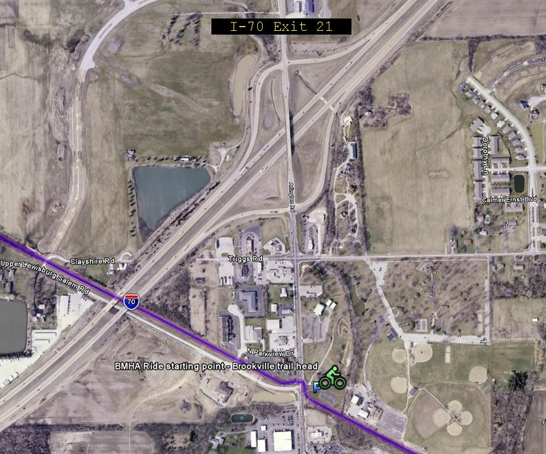

I hope that we can have a period of time for 'show and tell' of everyone's 'rolling ham shack' and to get on the air for a QSO before adjourning to eat Dinner.

It looks like a very easy ride on paved surface with a few street crossings but no riding 'with' traffic. There are some places to stop for food and drink along the trail too. Restrooms are on the other side of the park.

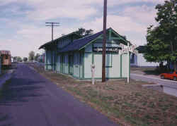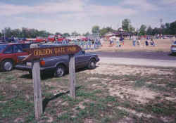

Picture on the left is the Brookville train station trail head, a couple of miles south of where we start, and on the right Golden Gate park ball field which is next to the trail head parking where we are going to start..
I hope that we have good weather and a great turn out. I am looking forward to seeing a lot of nice bicycle mobile stations!
Here are a few pictures gathered from the trail website, and another map:

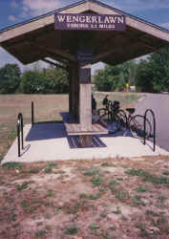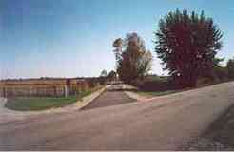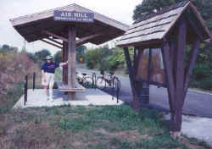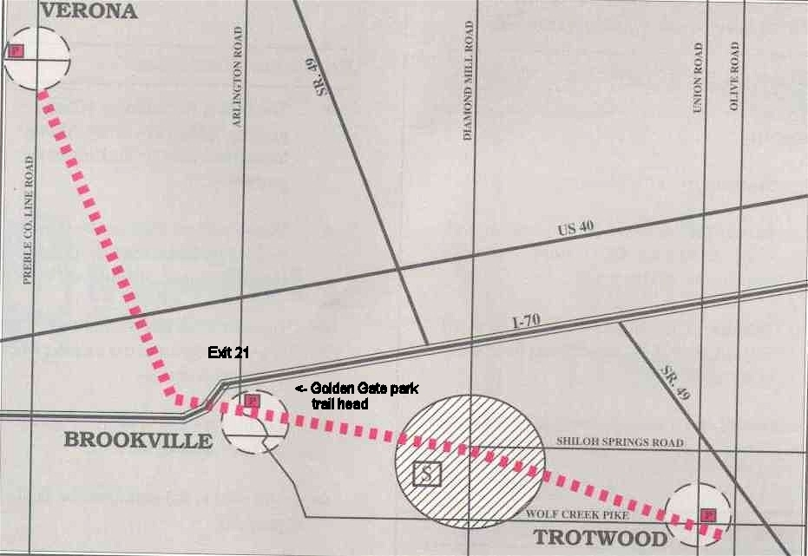

For updates or changes to the ride, please keep in touch via the BMHA forum on Yahoo Groups or the BMHA website.

Arnie, KA0NCR
BMHA 2009 Hamvention Ride Coordinator

